# Testing Log

### Bug #: 1

**Date:** 7/5/16

**Description:** Space in between the very top of the web browser and the table acting as a navigation bar. Space in between the very bottom of the web browser and the footer table.

**Solution:** Did a quick bit of Googling and fount that within the page properties window, on the CSS tab, set the margin for top and bottom to zero to remove the unneeded space.

### Bug: #2

**Date:** 8/5/16

**Description:** Carousal images and content are layed out down the left side of the page instead of being inside a slide show.

**Screenshot:** 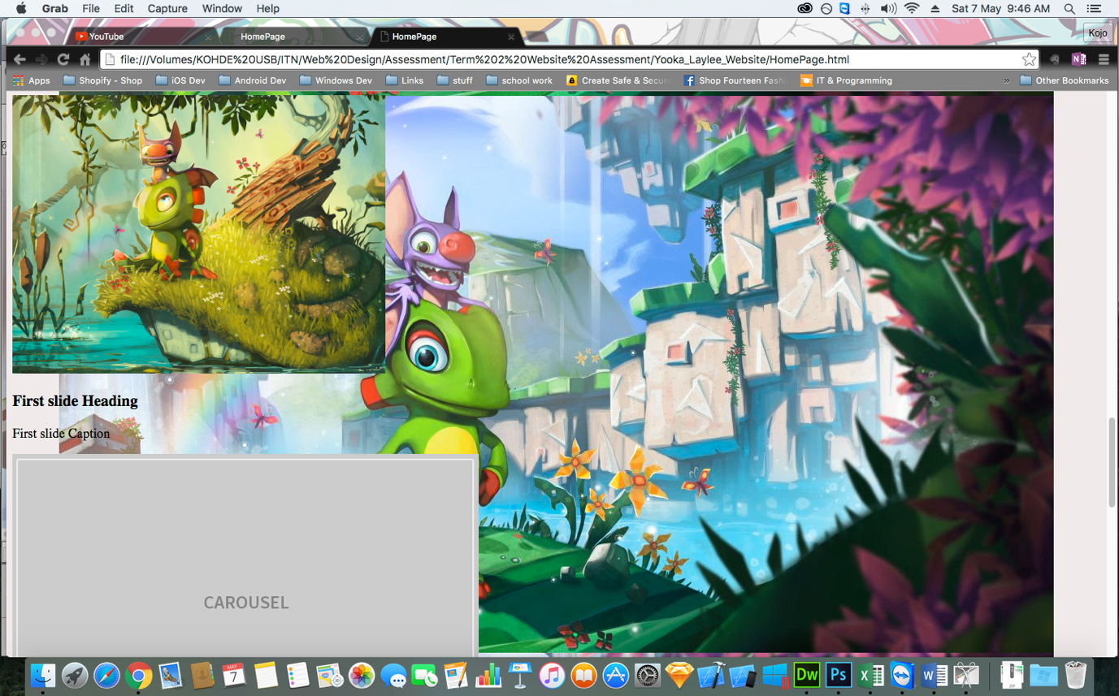

**Solution:** Replaced the carousal three times and Dreamweaver eventually corrected it.

### Bug #: 3

**Date:** 15/5/16

**Description:** Iframe widget for embedded Kickstarter page is being placed lower than the image its supposed to go next to.

**Screenshot:** 

**Solution:** Table width was not set correctly and so the Kickstarter widget was being pushed down instead of to the right of the image, used CSS to set the table to a width of 100%